GLOBAL CANIM
  - Importers of Sheet Metal & Custom Metal Products
About Us
Global Canim specializes in importing high-quality sheet metal and custom metal products from international markets to Canada. We are committed to providing durable, reliable, and competitively priced products to meet the needs of manufacturers, construction companies, and industrial clients.

Our Products
Image |  |  |  | PRICE
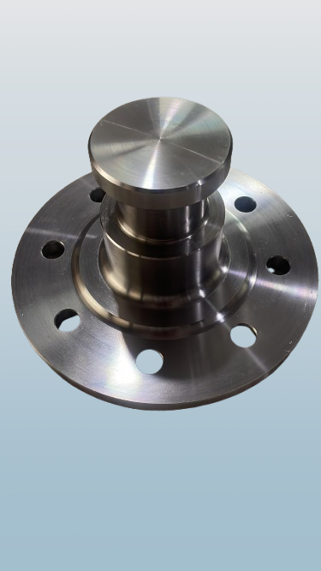 | Trailer King Pin |  |  | On Request

Trailer Kingpin
The Trailer Kingpin is a forged, heat-treated steel coupling device designed for reliable and secure connection between semi-trailers and tractor units, it ensures durability, safety, and smooth articulation during transport.
Our kingpins are manufactured with precision to resist wear, withstand heavy loads, and provide long service life under demanding road and off-road conditions.

Key Features:
- • High-strength forged steel construction
- • Heat-treated for maximum durability
- • Corrosion-resistant finish
- • Standardized for universal fifth wheel compatibility
- • Available in multiple sizes (2” and 3.5”)
- • Easy to install and maintain

Technical Specifications:
Specification | Details
Material | Forged, heat-treated alloy steel
Standard Sizes | 2” (Highway use), 3.5” (Heavy-duty)
Mounting | Weld-on or Bolt-on to bolster plate
Surface Finish | Black oxide or zinc-coated (anti-rust)
Applications | Semi-trailers, tankers, flatbeds, etc.

Applications:
- • Highway trailers
- • Heavy-duty mining and logging trailers
- • Tankers, flatbeds, container chassis
- • Specialized transport vehicles

Image | Product Name |  | Specifications
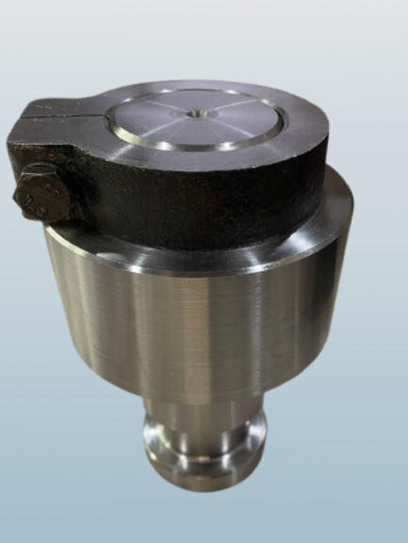 | TRAILER MAIN KING PIN SIDE LOCK |  | 1.SIDE LOCK CHECK NUT  2. HEX NUT  3. ROUND NUT

Image | Product Name | Description | Specifications | Price
[Insert Image] | Trailer Equalizer Pin |  | 50mm  York pin 51x290mm  York Pin 41mm  60mm  Double step 60mm | On Request

Product Name |  |  |  | Price
Trailer C Lock  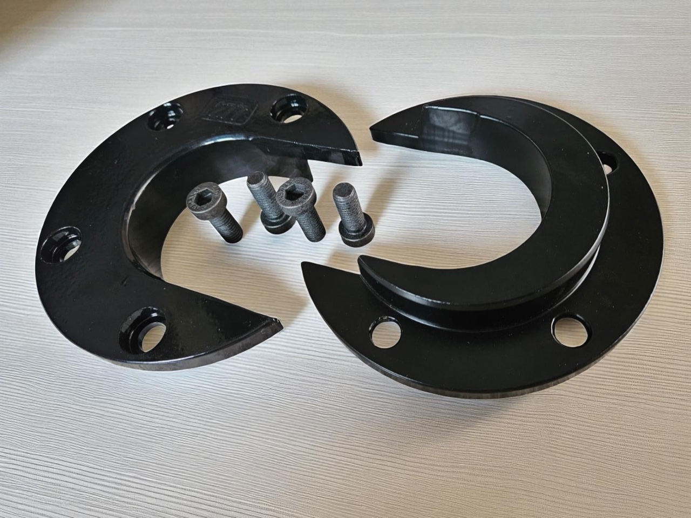 |  |  |  | On Request
Description -- A fifth-wheel lock, or kingpin lock, is a heavy-duty, C-shaped or solid steel device that secures to the trailer's kingpin to prevent theft or unauthorized towing. It works by wrapping around the exposed portion of the kingpin, locking into place with a key to block access to the locking jaw and bar of the fifth wheel coupling. These locks provide a physical deterrent to thieves, are made of strong, weather-resistant materials, and often include a visual warning tag and high-security keys to further enhance security.

Product Name

Fifth Wheel Hitch Pin
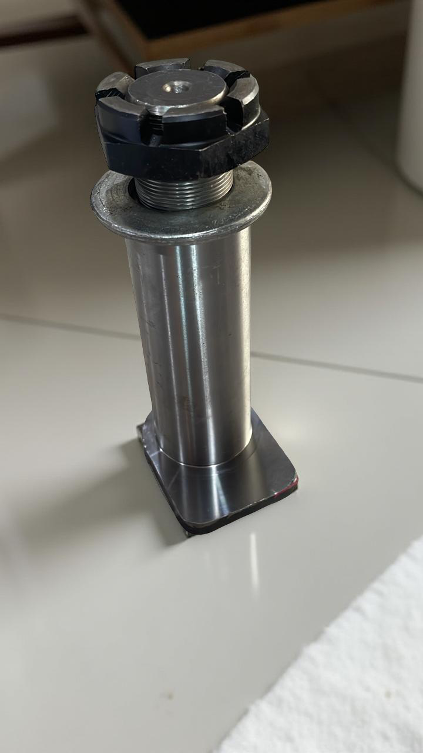
Spectification
# L type 50mm Pin
# 2 Hole Pin
# 4 Hole Pin

Product Name

J Lock
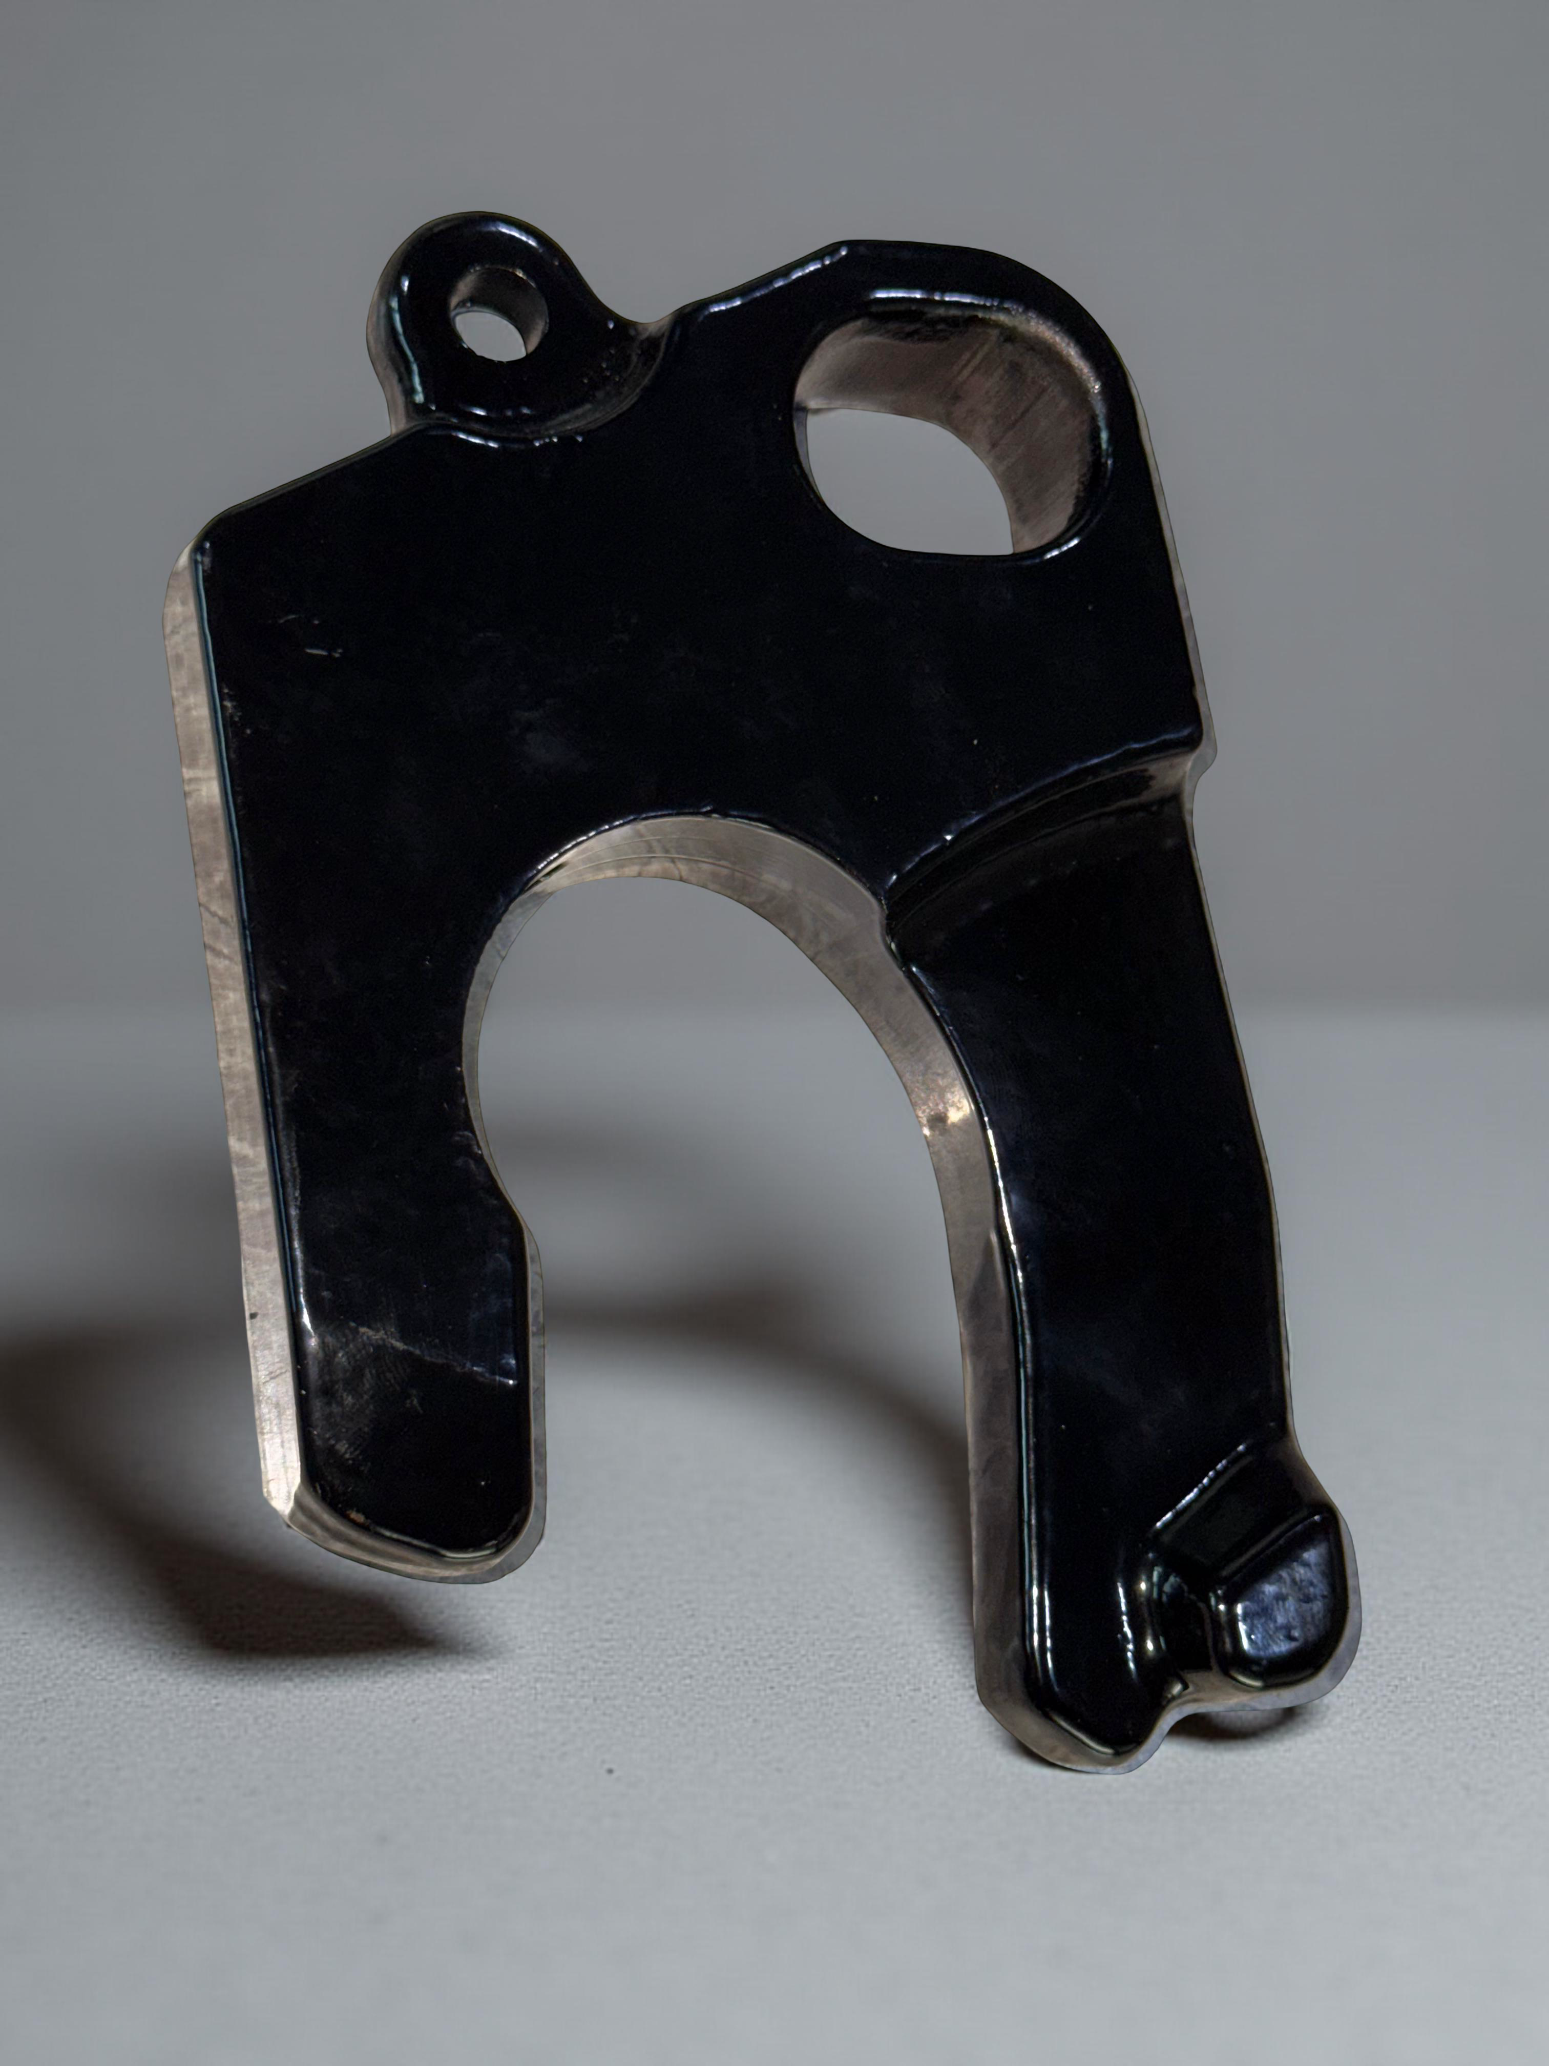
Description
A specialized wheel clamp that secures a vehicle's wheel, rather than a component of the fifth wheel hitch itself, though the user query could also be referring to the jaw and lock bar design within a fifth wheel.

Product Name

Propeller Shaft components
Cross Holder
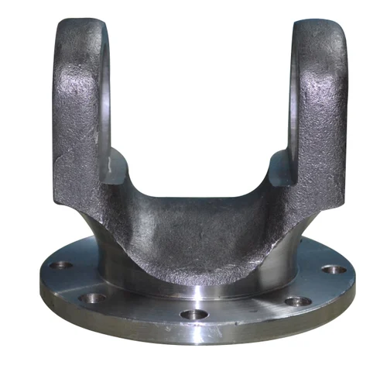
Description
A propeller shaft (or drive shaft) transmits rotational power from the engine and transmission to the drive wheels or propeller, allowing for non-aligned axes of rotation and generating thrust in marine applications.

Contact Us
Global Canim
Email: [Your Email Here]
Phone: [Your Phone Number Here]
Address: [Your Business Address Here]
Website: [Your Website Here]

